**In class Exercise – March 14, 2019 – Due on March 16 by 11:59pm**

**Objective: for and nested for loop, iomanip**

|  |
| --- |
| **Important instructions:**   * *All programs must include comments at the top of your program: your name,* the class name (CSIT 575)*, program name and* ***the program description (purpose of the program).*** * *Copy and paste your* ***program code*** *and* ***output*** *in Part B of each program. Note: Use snipping tool to snip the output.* * *Once it is done, save and submit this word file via Canvas.* |

1. **kiloToPound2.cpp (for loop, iomanip)**

Write a program to display the conversion from the odd number of kilograms to pounds from 1 to 50.

Given: 1 kilogram = 2.2 pounds

**Sample run 1**

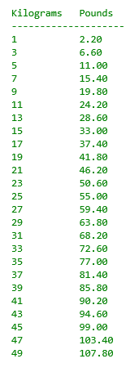

**Part B: Copy and paste your program (source) code and the outputs after this line.**

++++++++++++++++++++++++++++++++++++++++++++++++++++++++++++++++++++

**2. MultiplicationTable.cpp**

Write a program that uses **nested for** loops to print a multiplication table.

**Sample run**

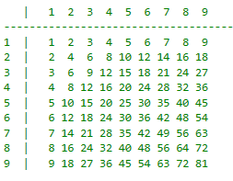

**Part B: Copy and paste your program (source) code and the outputs after this line.**

++++++++++++++++++++++++++++++++++++++++++++++++++++++++++++++++++++